Personal Information Management System Design Document v1

1 Introduction
This document describes the software design of the command-line Personal Information Management system specified in the SRS. The system manages notes, tasks, events, and contacts, and supports creation, modification, search, display, deletion, saving, and loading. This document explains the MVC architecture, the main software components and their interfaces, and the collaboration between components during a search-and-update scenario.

2 System Architecture
The system adopts the Model-View-Controller architectural pattern to separate terminal interaction from record-management logic. The view reads commands and displays responses, while the controller interprets commands and coordinates model operations. The model contains record definitions, validation, collection management, search criteria, and persistence.
This separation allows model operations to be tested without interactive terminal input and keeps terminal-specific code outside the required model package. In this implementation, the controller also assembles response messages and converts records into display strings, while the view handles terminal input and output.
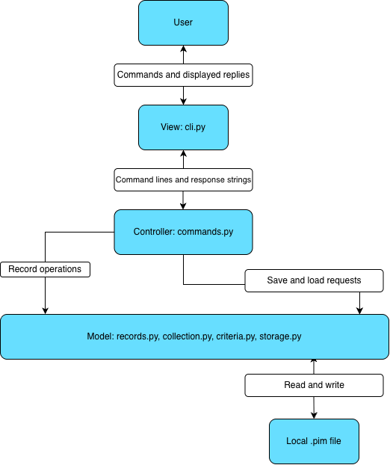
Figure 1. MVC architecture of the PIM system

Arrows from the controller to the model indicate operation requests; results return to the controller
Part | Actual file/module | Responsibility
View | view/cli.py | Read terminal input, display replies, manage the session loop
Controller | controller/commands.py | Interpret commands, call model operations, assemble responses, handle expected errors
Model | model/records.py | Define records and validate their values
Model | model/collection.py | Manage the active collection of records
Model | model/criteria.py | Parse and evaluate search conditions
Model | model/storage.py | Save and load .pim files

3 Main Components and Class Design
3.1 Record Classes

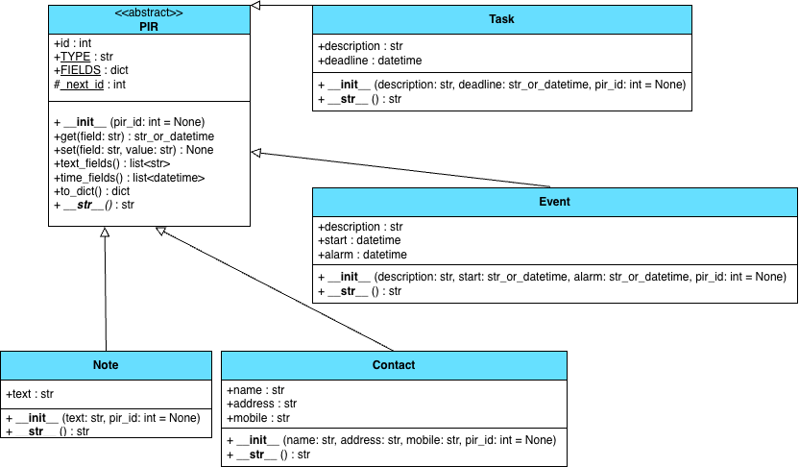
Figure 2. Record class hierarchy of the PIM system

PIR is the abstract base class for all personal information records. It provides a common ID, field access, field modification, and conversion to a dictionary. Note, Task, Event, and Contact inherit these operations and define their own fields and string representations. Each subclass defines TYPE to identify its record type and FIELDS to classify its fields as text or time values. This metadata allows modification, searching, and serialization to handle different record types consistently. Text values are validated before assignment, and time values are converted to datetime objects.
Class | Attributes | Purpose
PIR | id: int | Identifies a record.
PIR | TYPE: str, FIELDS: dict | Class-level metadata describing the record type and its fields.
PIR | _next_id: int | Shared class-level counter used to allocate IDs.
Note | text: str | Stores note content.
Task | description: str, deadline: datetime | Stores a task and its deadline.
Event | description: str, start: datetime, alarm: datetime | Stores event details and its start and alarm timestamps.
Contact | name: str, address: str, mobile: str | Stores contact details, preserving phone-number formatting.

Method | Parameters | Returns | Expected exceptions | Purpose
PIR.__init__ | pir_id: int | None = None | None | None for valid inputs | Assign an ID and advance the shared counter when necessary.
PIR.get | field: str | str | datetime | KeyError | Retrieve a supported field value.
PIR.set | field: str, value: str | None | KeyError, ValueError | Validate and replace a supported field value.
PIR.text_fields | None | list[str] | None for valid records | Return the record’s text values for searching.
PIR.time_fields | None | list[datetime] | None for valid records | Return the record’s time values for searching.
PIR.to_dict | None | dict | None for valid records | Produce record data for saving, formatting time values as strings.
__str__ | None | str | None for valid records | Return the record’s ID, type, and stored fields as display text.
All four constructors return None and may raise ValueError when required text or time values are invalid

Constructor | Parameters | Purpose
Note.__init__ | text: str, pir_id: int | None = None | Validate and initialize a note.
Task.__init__ | description: str, deadline: str | datetime, pir_id: int | None = None | Validate the description and convert the deadline to a datetime.
Event.__init__ | description: str, start: str | datetime, alarm: str | datetime, pir_id: int | None = None | Validate the description and convert the start and alarm times.
Contact.__init__ | name: str, address: str, mobile: str, pir_id: int | None = None | Validate and initialize contact details.
Types not explicitly annotated in the source code are inferred from the implementation. Python does not declare checked exceptions; the tables list expected exceptions during normal use.

3.2 Collection and Controller

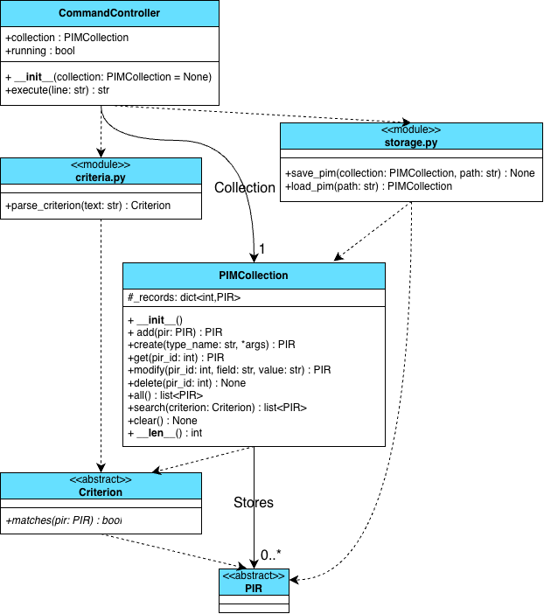
Figure 3. Main components and dependencies of the PIM system.

PIMCollection manages the active records using the _records dictionary which maps integer IDs to PIR objects. It provides creation, retrieval, modification, deletion, and searching operations. Modification delegates field validation to PIR.set(), while searching calls matches() on the supplied criterion for each record. Results are returned in ascending ID order.
CommandController holds the active collection and a Boolean running flag. Its execute() method identifies the command and dispatches it to the corresponding command handler. The controller converts expected ValueError, KeyError, and OSError exceptions into error messages for the view. A successful load replaces its collection reference, while the quit command sets running to False.

Method | Parameters | Returns | Expected exceptions | Purpose
__init__ | None | None | None | Initialize an empty record dictionary.
add | pir: PIR | PIR | None for valid records | Store a record using its ID and return it.
create | type_name: str, *args: record constructor arguments | PIR | ValueError; TypeError for incorrect constructor arguments | Construct and store the selected record type.
get | pir_id: int | PIR | KeyError | Retrieve a record by ID.
modify | pir_id: int, field: str, value: str | PIR | KeyError, ValueError | Validate and update one field, then return the record.
delete | pir_id: int | None | KeyError | Remove the specified record.
all | None | list[PIR] | None for valid records | Return all records in ascending ID order.
search | criterion: Criterion | list[PIR] | None for valid criteria and records | Return records satisfying the criterion in ascending ID order.
clear | None | None | None | Remove all records from the collection.
__len__ | None | int | None | Return the number of stored records.

Method | Parameters | Returns | Expected exceptions | Purpose
CommandController.__init__ | collection: PIMCollection | None = None | None | None for valid inputs | Keep the supplied collection or create an empty one; initialize running to True.
CommandController.execute | line: str | str | Handles ValueError, KeyError, and OSError internally | Process a command and return response text. Empty input returns an empty string.
The view/cli.py module provides run_cli(controller: CommandController | None = None) -> None. It reads commands while the controller’s running flag is True, passes each command to execute(), and displays non-empty responses. EOFError and KeyboardInterrupt are handled to end the session.

3.3 Search Criteria
The search mechanism uses the abstract Criterion class, which defines matches(pir: PIR) -> bool. Each concrete criterion checks whether a record satisfies a particular condition. PIMCollection.search() applies the criterion to each record and returns matching records in ascending ID order.
TypeCriterion filters records by type. ContainsCriterion performs case-insensitive substring matching across text fields. TimeCriterion compares the record’s time fields with a specified datetime using <, >, or =. AndCriterion, OrCriterion, and NotCriterion combine criteria to support more complex searches.
Class | Main attributes | Constructor parameters | Matching behaviour
TypeCriterion | type_name: str | type_name: str | Checks the record type.
ContainsCriterion | needle: str | needle: str | Checks whether any text field contains the search text, ignoring case.
TimeCriterion | op: str; when: datetime | op: str; when: str or datetime | Checks whether any time field satisfies the comparison.
AndCriterion | left: Criterion; right: Criterion | left: Criterion; right: Criterion | Returns True when both criteria match.
OrCriterion | left: Criterion; right: Criterion | left: Criterion; right: Criterion | Returns True when either criterion matches.
NotCriterion | inner: Criterion | inner: Criterion | Returns the opposite of the inner criterion’s result.
All six concrete classes inherit from Criterion and implement matches (pir: PIR) -> bool. Their constructors return None. AndCriterion and OrCriterion each hold references to two Criterion objects, while NotCriterion holds a reference to one. These relationships allow nested search expressions. TimeCriterion raises ValueError when an unsupported comparison operator or an invalid datetime string is supplied.
The criteria.py module provides parse_criterion(text: str) -> Criterion. It converts a search expression into a criterion object or a combination of criterion objects. The parser supports parentheses and applies operator precedence in the order NOT (!), AND (&&), then OR (||). Empty or invalid expressions raise ValueError, which CommandController.execute() catches and converts into an error message.
3.4 Persistence
The storage.py module handles saving and loading records using local .pim files. Each record is stored as one JSON object per line, including its type, ID, and field values. Datetime values use the format YYYY-MM-DD HH:MM. This format allows records to be reconstructed with their original types and IDs.
The storage functions are separate from the command controller and record classes. CommandController calls save_pim() to save the current collection and load_pim() to create a collection from a file. The controller replaces its active collection only after loading completes successfully. If loading fails, the existing active collection remains available.
Function | Parameters | Return type | Exceptions | purpose
save_pim | collection: PIMCollection; path: str | None | ValueError; OSError | Saves all records in ascending ID order, replacing the file’s existing contents.
load_pim | path: str | PIMCollection | ValueError; OSError | Reads and validates records, then returns a new collection.
_check_ext | path: str | None | ValueError | Checks that the file extension is .pim, ignoring case.
During loading, blank lines are ignored. Each remaining line must contain a valid JSON record with a supported record type, a unique positive integer ID, and valid field values. Invalid records cause ValueError with line information. File access failures raise OSError. CommandController.execute() catches these exceptions and returns an error message to the user.

4 Search and Update Interaction
Precondition: The active collection contains a task with ID 3. The user first enters search type=task. After identifying Task 3 in the search results, the user enters modify 3 deadline “2026-11-15 18:00”.
Postcondition: Task 3 has the new deadline. Its ID, type, description, and all other records remain unchanged.

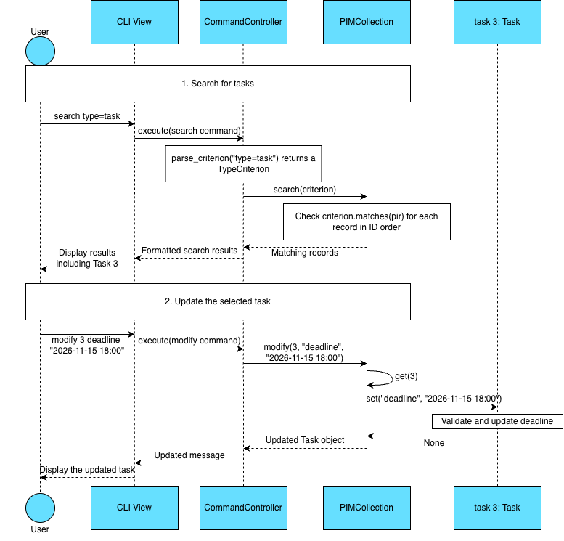
Figure 4. Sequence of searching for tasks and updating a selected task

The controller parses the search criterion and asks the collection for matching records. After the CLI displays the results, the user selects Task 3 by ID and enters a separate command to change its deadline. The collection retrieves the task and calls its set() method to validate and apply the new deadline. The CLI then displays the update confirmation.

5 Design Decisions and Requirements Traceability
Design choice | Reason | Related user stories
PIR Inheritance | Reuse common field access, validation, and serialization behaviour | US1-US6
Criterion hierarchy | Evaluate simple and combined search conditions through a common interface | US7
ID-based collection | Select a specific record for modification, display, or deletion | US6, US8, US9
Validate before updating | Preserve existing values when replacement input is invalid | US6
Load into a new collection before replacement | Preserve active records if loading fails | US11
JSON Lines persistence | Store and restore record types, IDs, and fields | US10-US11

